INTERACTIVE AND VISUALLY APPEALING DASHBOARD

Creating an interactive and visually appealing dashboard helps users easily understand smartphone usage patterns digital well-being. The dashboard presents important information using different visualizations and interactive filters.
DASHBOARD FEATURES:
- Clear and Intuitive layout
- Relevant Visualizations
- KPI Cards
- Interactive Filters and Slicers
- Charts and Graphs
- Easy-to-understand Design
- Age Group and Gender Analysis
- Addiction Level Analysis

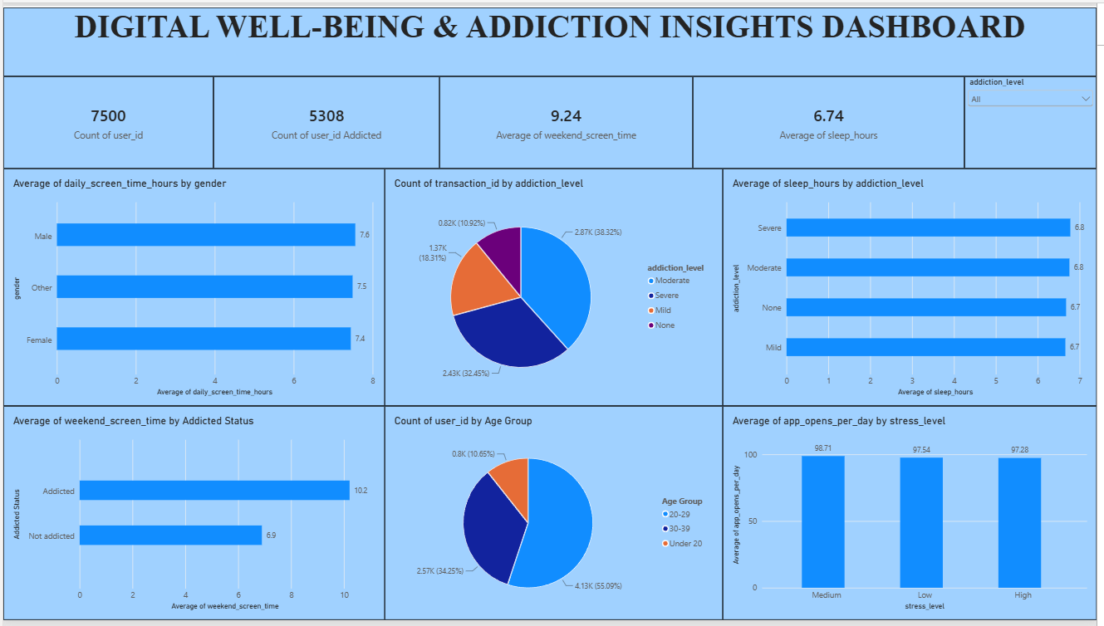

Potential Outcomes from Dashboard Visualization:

- Screen Time Analysis: The dashboard shows the average daily screen time of users.
- Addiction Analysis: The dashboard shows users according to different addiction levels such as None, Mild, Moderate and Severe.
- Gender Analysis: The dashboard compares average screen time among different genders.
- Age Group Analysis: The dashboard compares screen time across different age groups.
- Digital Activity Analysis: The dashboard compares gaming, social media, app usage and notifications.
- Sleep Analysis: The dashboard helps examine screen time and sleep-hour patterns.
- Weekend Usage: The dashboard displays the average weekend screen time.
- Overall Digital Well-Being: KPI cards provide a quick summary of important digital usage measures.

